**2021 EDAA Online Exhibition**

**Welcome page:**

This exhibition marks the seventh edition of the Emerging Digital Artists Award (EDAA) with five exceptional works that expand the limits of digital art practice. The 2021 award winners were selected from over 175 submissions by emerging artists across Canada in recognition of their innovative approach to digital technologies and ability to generate bold new worlds in digital space.   
  
The five works share a common pursuit in pushing the capacities of digital media to better connect us to our physical selves and surroundings: Aljumaine Gayle’s interactive installation tracks and monitors our presence in the gallery, prompting an awareness of how physical bodies and digital data intersect in (supposedly) public spaces; Erin Konsmo brings the land-based practice of fish scale art to wider audiences using macro photography, paying reverence to whitefish and their habitat by exposing the intricate details of a single fish scale; Katelyn Hawley’s game implicates us in a mission to escape isolation during a global pandemic, where both the material world and our inner thoughts must be contested and overcome; Olivia Dreisinger’s experimental documentary reveals how online communities create new possibilities for living through the genre of disability-themed fanfiction; and Shonee leads us on a meditative journey through a lush and thriving virtual ecosystem which acts as an artificial stand-in for an environment in a post-climate-emergency world. Each work is rooted in the revelatory, drawing our awareness to a current reality and the possible futures ahead.

We want to thank this year’s guest judges—Ashley Jane Lewis, Cat Bluemke, and Suzanne Morrissette—whose insight and expertise helped inform an incredible selection of works. We also want to thank artist Khadija Aziz, whose series *Slippery Spaces* (2018-2021) informed the look and feel of this year’s award. We are grateful to our colleagues at Trinity Square Video and EQ Bank for their invaluable contributions to this exhibition. And last but certainly not least, special thanks and congratulations to the award winners: Aljumaine, Erin, Katelyn, Olivia, and Shonee.

**Emily Fitzpatrick**, Artistic Director, Trinity Square Video   
and **Shannon Linde**, Curator, EQ Bank

**Exhibition pages:**

**Aljumaine Gayle**  
*Twenty_Four_Seven / 365*, 2019  
Interactive Installation

*Twenty_Four_Seven / 365* is an immersive interactive installation that illustrates the rising dangers of surveillance technology for communities of colour, including its ability to regulate behaviour in both subtle and overt ways. Pointing to specific technological advancements that have given police departments and governments increased capabilities to monitor, track, and punish specific groups, the work aims to provoke reflection on the nature of privacy and consent in public spaces in hopes of sparking an inclusive dialogue among audiences.

[Aljumaine Gayle](http://aljumaine.com/) is a queer artist and creative technologist working at the intersections of tech, art, design, and data justice. Their artistic practice explores and subverts the othering of blackness in contemporary life. Aljumaine is a student in OCAD University’s Digital Futures program and a researcher with the University of Toronto’s Technoscience Research Unit.

---

**Erin Konsmo**  
*Fish/Scale Cones*, 2020  
Image

*Fish/Scale Cones* takes fish scale art into the digital realm. The time-intensive artform includes catching whitefish, processing the scales, then dyeing and organizing them into careful compositions—a practice that is based on relationships with the water, local First Nations and Métis fishers, and the fish themselves. Konsmo plays with the idea of ‘scale’ using macro photography, layering physical fish scales over top of digital images of enlarged scales to create traditional floral forms, prompting close attention to the intricate details of this important material.

[Erin Konsmo](http://www.erinkonsmo.com/) is a Métis Prairie queer who grew up in central Alberta and is a member of the Métis Nation of Alberta. Their artistic practice currently focuses on fish scale art, an artform they were mentored into by Métis artist Jaime Morse. Erin is an advocate for the water, land and fish.

---

**Katelyn Hawley**  
*Stuck*, 2021  
Game

*Stuck* is an exploratory game with the objective of guiding a small seedling on an introspective journey out into the world, where they must face their personified negative feelings in order to better understand themselves. Taking inspiration from anti-role-playing games such as *Yume Nikki* and *Mother*, *Stuck’s* character interactions range from comical to bleak to overwhelming. As the player traverses a series of mental planes and abstract landscapes, they come to empathize with the seedling’s mindset and join in the quest for self-acceptance.

[Katelyn Hawley](https://katehawley.format.com/) is a recent graduate from OCAD University's Expanded Animation program, originally from Halifax, Nova Scotia. Her game-based works explore how nonconventional characters move and interact with the world, blending fluid animation and surreal storytelling to leave a lasting impact on players.

---

**Olivia Dreisinger**  
*disabled!*, 2017  
Video, 41:04

*disabled!* is an experimental video documentary that examines the role of disability in fanfiction. Narrated through a fan-made avatar of River Tam from the television show *Firefly*—a non-visibly disabled character that serves as a stand-in for the artist’s own imperceptibly unwell body—viewers are taken on a tour of the many worlds of fanfiction. Paralleling the inherent inquisitiveness and ingenuity of the genre with the artist’s own quest for alternate ways of living, the work creates space to challenge and reimagine our understanding of disability.

[Olivia Dreisinger](http://oliviadreisinger.com/) is a disability scholar, filmmaker, and writer. Her own fluctuating abilities often dictates how she produces work—a process that regularly leads her to new and generative mediums to explore. She splits her time between Victoria and Vancouver, Canada.

----

**Shonee**  
*Field of Reeds*, 2021  
Video, 6:08

*Field of Reeds* is a 360-degree video that explores nature’s position within the urban landscape. Accessed through the sterility of a computer screen, a simulated virtual plant biome offers an escape from a future reality where all plants and animals have gone extinct. Physical movement is restricted within the vast digital ecosystem to ground the “user” in place as their perception slows to the pace of the surrounding flora, their attention drawn to the meditative stillness of plant life moving in cycles to reflect the environment's slow moving circadian rhythm.

[Shonee](http://shonee.space/) is a Canadian-Costa Rican digital media artist based in Montreal who uses the immersive potential of video and speculative fiction to create artificial life. In the virtual worlds she creates, surreal creatures embody humankind’s objective and narrow misunderstanding of the lives of plants and animals in this time of ecological crisis.

**Biographies:**

[Aljumaine Gayle](http://aljumaine.com/) is a queer artist and creative technologist working at the intersections of tech, art, design, and data justice. Their artistic practice explores and subverts the othering of blackness in contemporary life. Aljumaine is a student in OCAD University’s Digital Futures program and a researcher with the University of Toronto’s Technoscience Research Unit.

[Erin Konsmo](http://www.erinkonsmo.com/) is a Métis Prairie queer who grew up in central Alberta and is a member of the Métis Nation of Alberta. Their artistic practice currently focuses on fish scale art, an artform they were mentored into by Métis artist Jaime Morse. Erin is an advocate for the water, land and fish.

[Katelyn Hawley](https://katehawley.format.com/) is a recent graduate from OCAD University's Expanded Animation program, originally from Halifax, Nova Scotia. Her game-based works explore how nonconventional characters move and interact with the world, blending fluid animation and surreal storytelling to leave a lasting impact on players.

[Olivia Dreisinger](http://oliviadreisinger.com/) is a disability scholar, filmmaker, and writer. Her own fluctuating abilities often dictates how she produces work—a process that regularly leads her to new and generative mediums to explore. She splits her time between Victoria and Vancouver, Canada.

**About Page:**

**2021 EDAA Exhibition**  
**September 10 – October 2, 2021**

The 2021 EDAA Exhibition brings together the five award-winning artworks by Aljumaine Gayle, Erin Konsmo, Katelyn Hawley, Olivia Dreisinger, and Shonee. The exhibition is viewable both online and in the gallery at [Trinity Square Video](https://www.trinitysquarevideo.com/exhibition-2021-emerging-digital-artists-award/)

**Online Exhibition**:  
Web Design: Caitlin Haaf, 2021  
Cover artwork: Khadija Aziz, *Silky Waterfalls,* 2020  
Exhibition artworks: Courtesy of the artists  
  
**TSV Exhibition:**  
Installation: José Andres Mora  
Printing: Saman Designs  
Documentation: Yuula Benivolski

--

The [Emerging Digital Artists Award](https://edaa.eqbank.ca/) (EDAA) is Canada’s major award for critical experimentation in digital media, proudly presented by Trinity Square Video and EQ Bank. Established in 2015, the annual award celebrates the contributions of early-career, screen-based artists working exclusively in virtual space. Each year, we seek artwork submissions from across the country that push us in new directions and challenge us to see the world through a different screen.

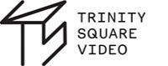 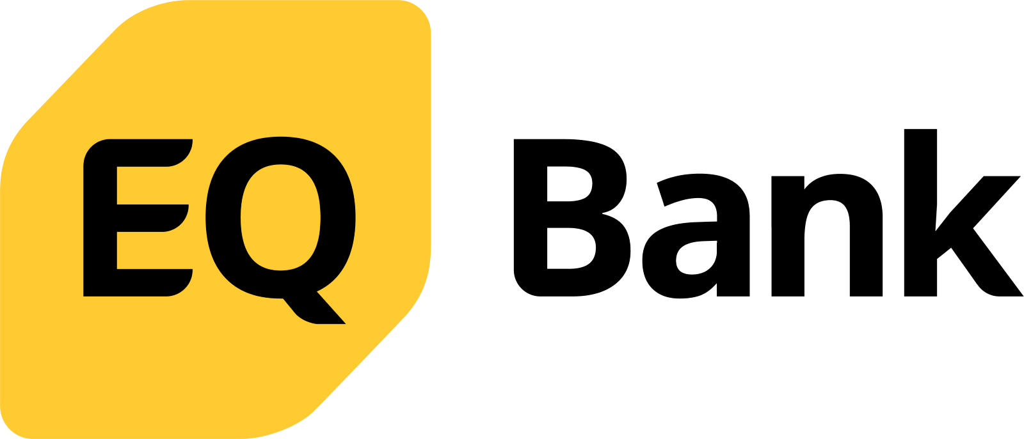

[Trinity Square Video](https://www.trinitysquarevideo.com/) is a space to re-imagine media arts. As video-based practices have become increasingly present across disciplines, Trinity Square engages artists and curators in critical investigations into the changing conditions of perception, materiality, and the virtual.

[EQ Bank](https://www.eqbank.ca/) is the digital banking platform launched in 2016 by Equitable Bank, Canada’s Challenger Bank™. As a future-ready financial institution, fostering innovation is at the heart of everything we do. We firmly believe in the benefits of open banking and continue to invest in technology to serve the changing and growing financial needs of Canadians.